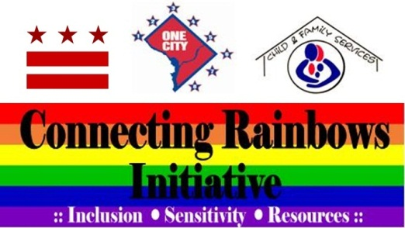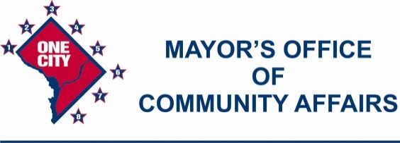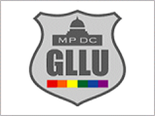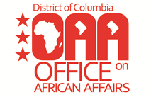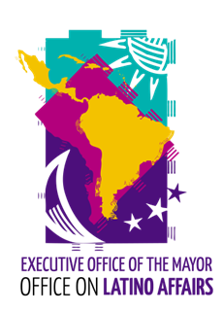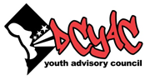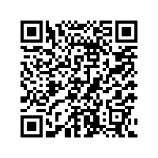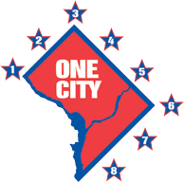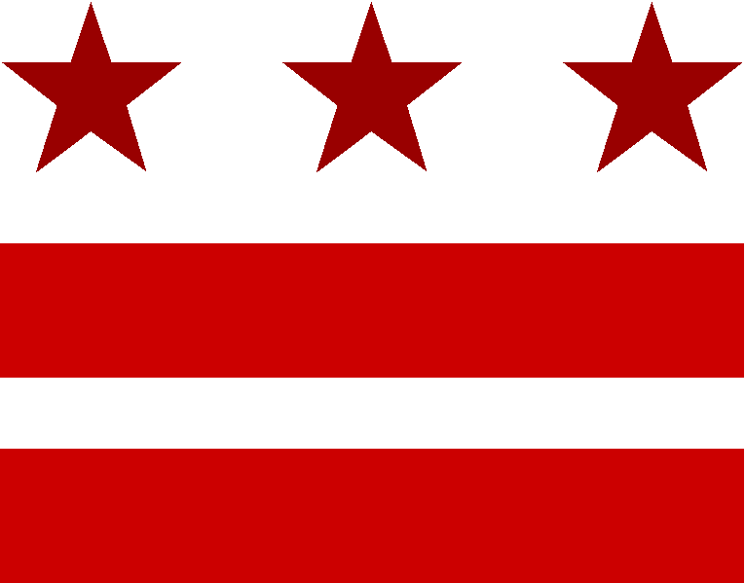

**Questions? Contact the D.C. Youth Advisory Council Office at 202.727.7968, or email at** [**dcyac@dc.gov**](mailto:dcyac@dc.gov)**,**

**Office of Gay, Lesbian, Bisexual and Transgender Affairs**

**202.727.9493 or email at** [**glbt@dc.gov**](mailto:glbt@dc.gov)**.**

**If you require translation or an interpreter,**

**please call 202.442.8150.**

**12:00pm – 2:00pm**

**Eastern Market’s North Hall**

**225 7th Street, S.E.**

**Washington, D.C. 20003**

**Eastern Market Metro Station (Orange/Blue Line)**

**Follow the D.C. Youth Advisory Council on Facebook and Twitter!**

**Government of the District of Columbia**

**Executive Office of the Mayor**